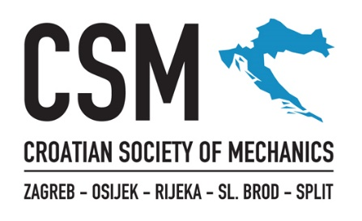
Ivana Lučića 5
HR-10000 Zagreb, Croatia
OIB: 97479051596
T: 01 61 68 540
F: 01 61 68 506
E-mail: contact@csm.hr
www.csm.hr

CONSENT FOR THE USE OF PERSONAL DATA

By signing this consent, I,

First name
Last name
Date and place of birth
OIB (Croatian Tax ID)*
Street Address
Postal Code, City
* Alternatively: personal/national identification number AND passport or ID card number.

I declare that I have been fully informed about the Privacy Policy of the Croatian Society of Mechanics and that I give my voluntary, explicit, and unequivocal consent for the collection and processing of my personal data by the Croatian Society of Mechanics, Ivana Lučića 5, HR-10000 Zagreb, OIB: 97479051596, in accordance with applicable legal regulations, for the following purposes:
- keeping membership records, administration, and management of the Society;
- marketing purposes (sending information via e-mail);
- publication of name and surname as a member on the Society’s website.

Place and Date Signature

Consent for the Use of Personal Data should be submitted as a scanned copy via e-mail to contact@csm.hr or sent by post to the address of the Society.

